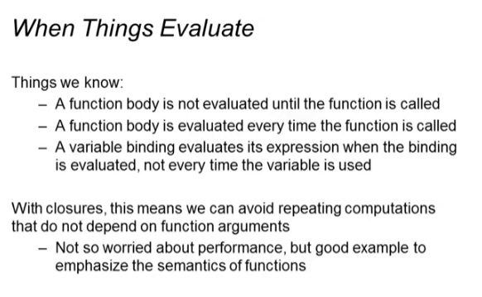

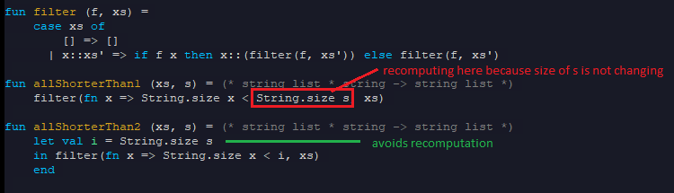

* Longer function body but there is a performance difference!
* This is also more readable

Showing the difference using “print” statement & semi-colon expression (;)

* Takes a string -> prints it out
* ; -> does the left side then throw the result, does right side for the whole thing
  + eg: e1 ; e2
  + Does e1, throws away the result then does e2 for the whole thing

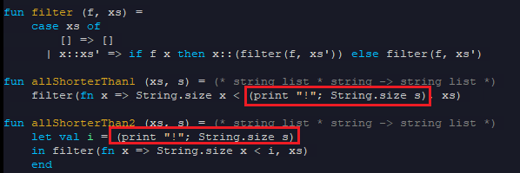

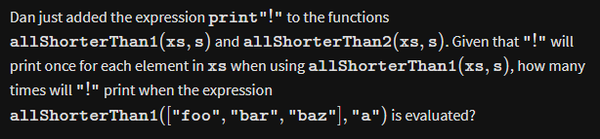

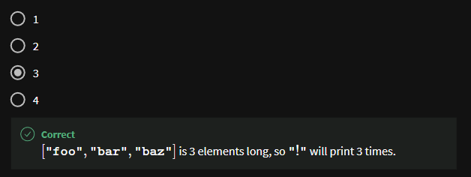

Checking the result using tests

